
9
SPEAR

Surveying and Planning through Electronic Applications and Referrals



SPEAR Release Notes

Release 5.15

The following functional changes to SPEAR have been included in Release 5.15:
 | Users Impacted | Feature | Description
 | Applicant Contacts | Owners Corporation Details enhancements  - CR 5843 | Several enhancements have been made to Owners Corporation (OC) Details in SPEAR:  - Applicant contacts now only need to digitally sign the OC Details before release for lodgement if a new OC is being created by the plan. SPEAR will no longer prompt users to digitally sign the OC Details for an existing OC or where no OC is required.  - When opening the OC Details, SPEAR will now show the Owners Corporation Additional Information (OCAI) on screen by default, rather than downloading the .XLSX spreadsheet. Users who wish to download the .XLSX spreadsheet can still do so from the new hyperlink added to the top-right of the screen.  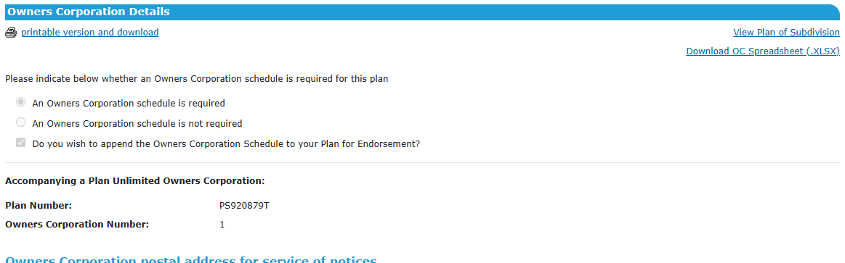  - For a Limited to Common Property OC, the ‘Details of the limitations’ field will now be shown on screen and on the rendered Owners Corporation Additional Information (OCAI) form. This field will be pre-populated with the text “Not required – limited to common property” and will not be editable.  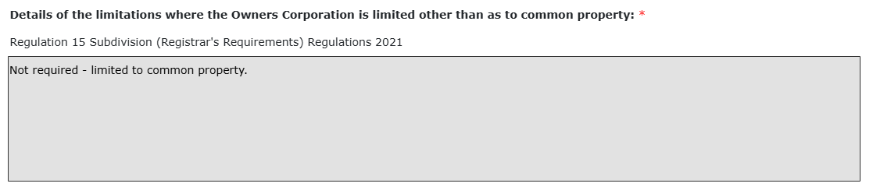  - For an Unlimited OC, the ‘Purposes of the OC’ field will be pre-populated with the text “The purpose of the owners corporation is to manage the land affected by the owners corporation (except the use of any common property affected by a limited owners corporation)” and will remain editable.  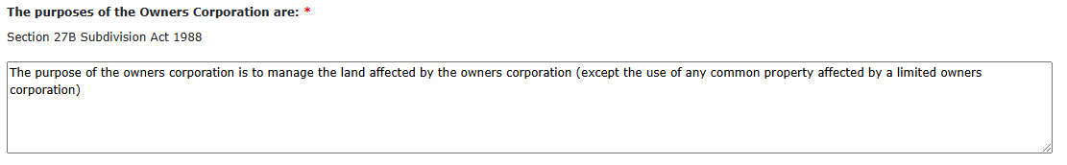
 | Applicant Contacts | Ensure the latest ePlan validation service version has been used when signing the ePlan Validation Report  - CR 5847 | SPEAR will check the version of the ePlan validation service used whenever the ePlan Validation Report is digitally signed. If the ePlan has been validated using an older version of the service, applicant contacts will be prompted to revalidate the ePlan. This will ensure applicant contacts are receiving and responding to the latest ePlan validation rules.  Additionally, the ePlan Validation Report will no longer need to be digitally signed using a separate signing action. It can now be signed alongside documents such as the Abstract of Field Records and Surveyor’s Report.
 | All users | Provide additional information and documents in calls to DCAS  - CR 5864 | SPEAR now sends additional information and documents to the Digital Cadastre Automation Service (DCAS) for processing.
 | All users | N/A | SPEAR no longer supports entering angle brackets < or > in text fields. Please use an alternative type of bracket in SPEAR if needed.  Note that PDFs uploaded to SPEAR are still able to contain angle brackets.

